

**Advanced Software Engineering**

Course # CSEE 5551 0001

Semester: Spring 2017

LAB Assignment # 5

Submission Date: 2/15/2017

Student Name: Satya Sai Deepthi Katta

Student ID: 16231371

**Instructor:** Dr. Yugyung Lee

**Email:** LeeYu@umkc.edu

**Department of Computer Science & Electrical Engineering**

**University of Missouri, Kansas City**

**Welcome to Lab Assignment #5 Wiki Page!**

Submission on 2/22/17

**TASK: Create WireFrames for Android Application.**

**To present the rough view of the Android Application, Wireframes are created using online web service called creately.com.**

**Below provided are the screenshots for Wireframes of the My Location Android Application.**

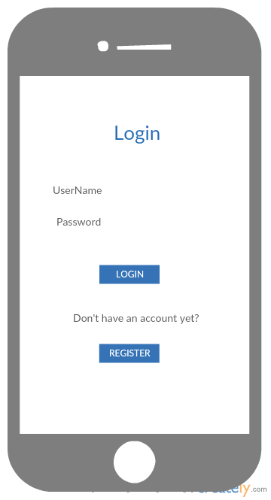

**Fig 1. Wireframe for Login Page of Android App.**

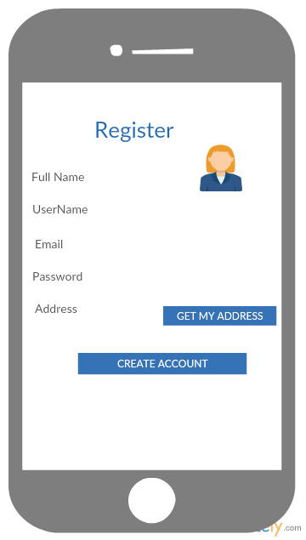

**Fig 2. Wireframe for Registration Page of Android App.**

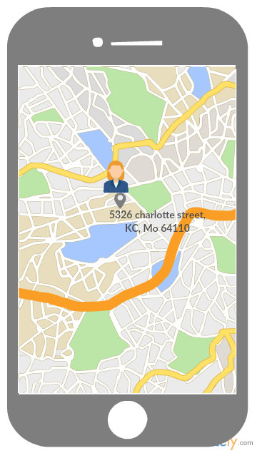

**Fig 3. Wireframe for Word Search Android App.**

**TASK 1: Create an Android application for users’ signup**

An Android application is created using GOOGLE MAPS API, which displays the current location of the address and displays the image uploaded or captured at that point of time.

On launching the Application, the first screen is the login page

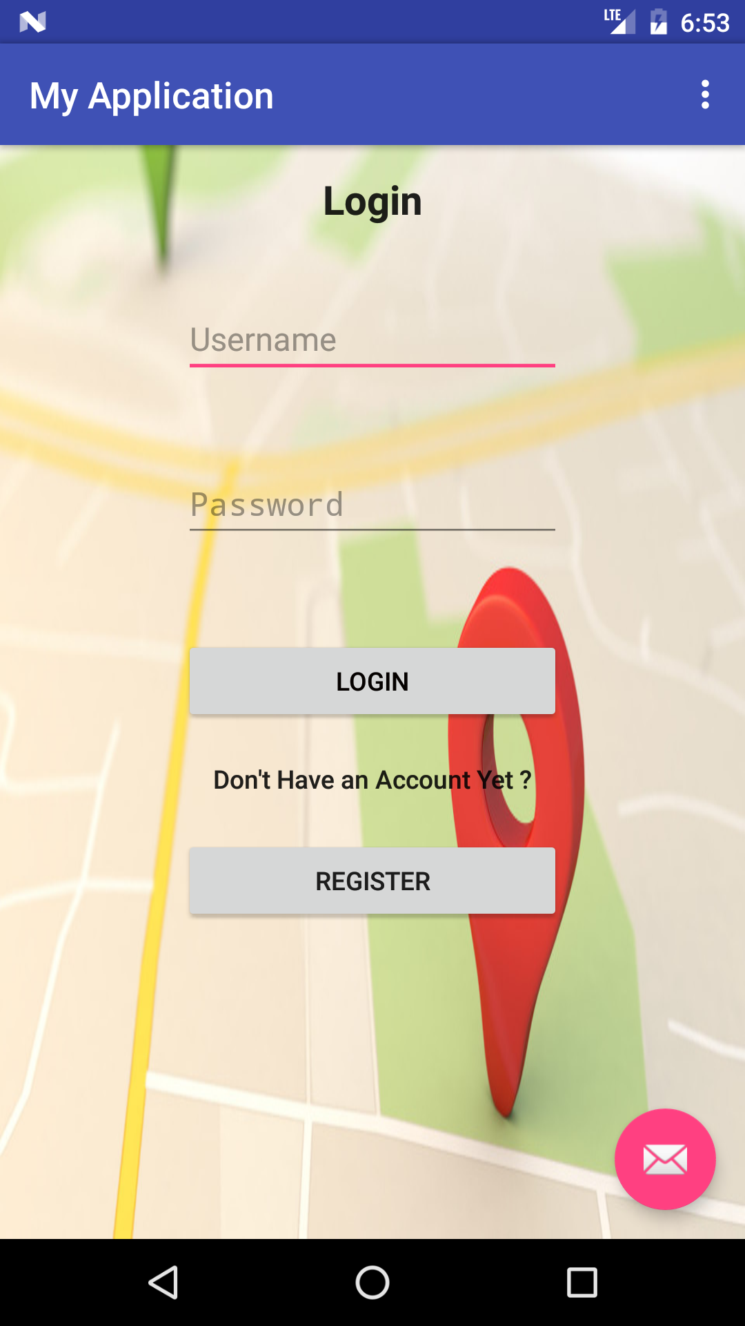

Fig 4. Login Page for the Application.

Initially, any new user must register into the application by adding their email address, full name of the user and setting up a password.

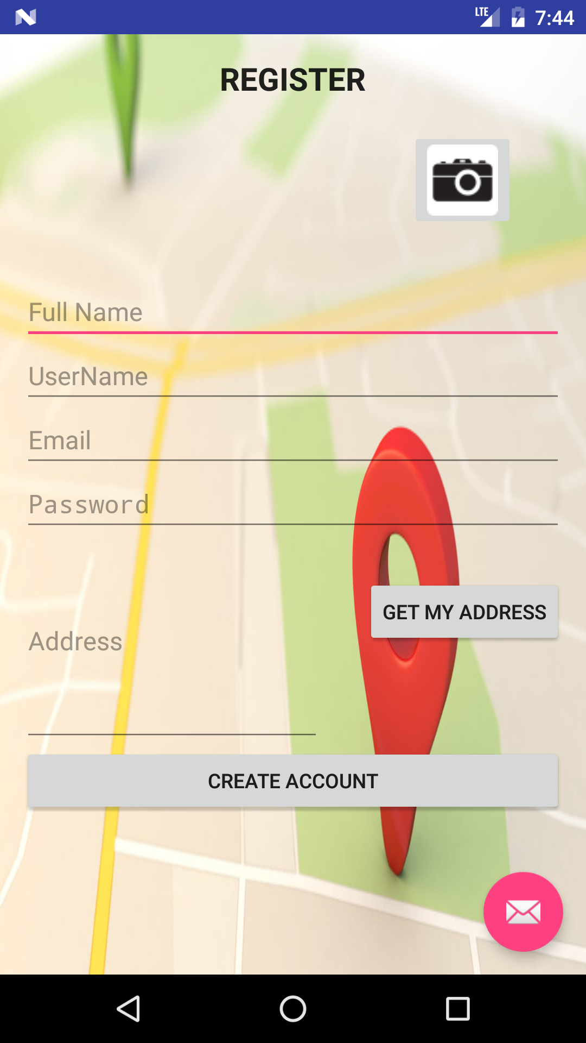

**Fig 5. Registration Page of the Android App.**

Entering the correct credentials, login will move to home page, where the current location address is displayed along with the image inserted.

A new user ADMIN is created for the Application.

The screenshot is provided below:

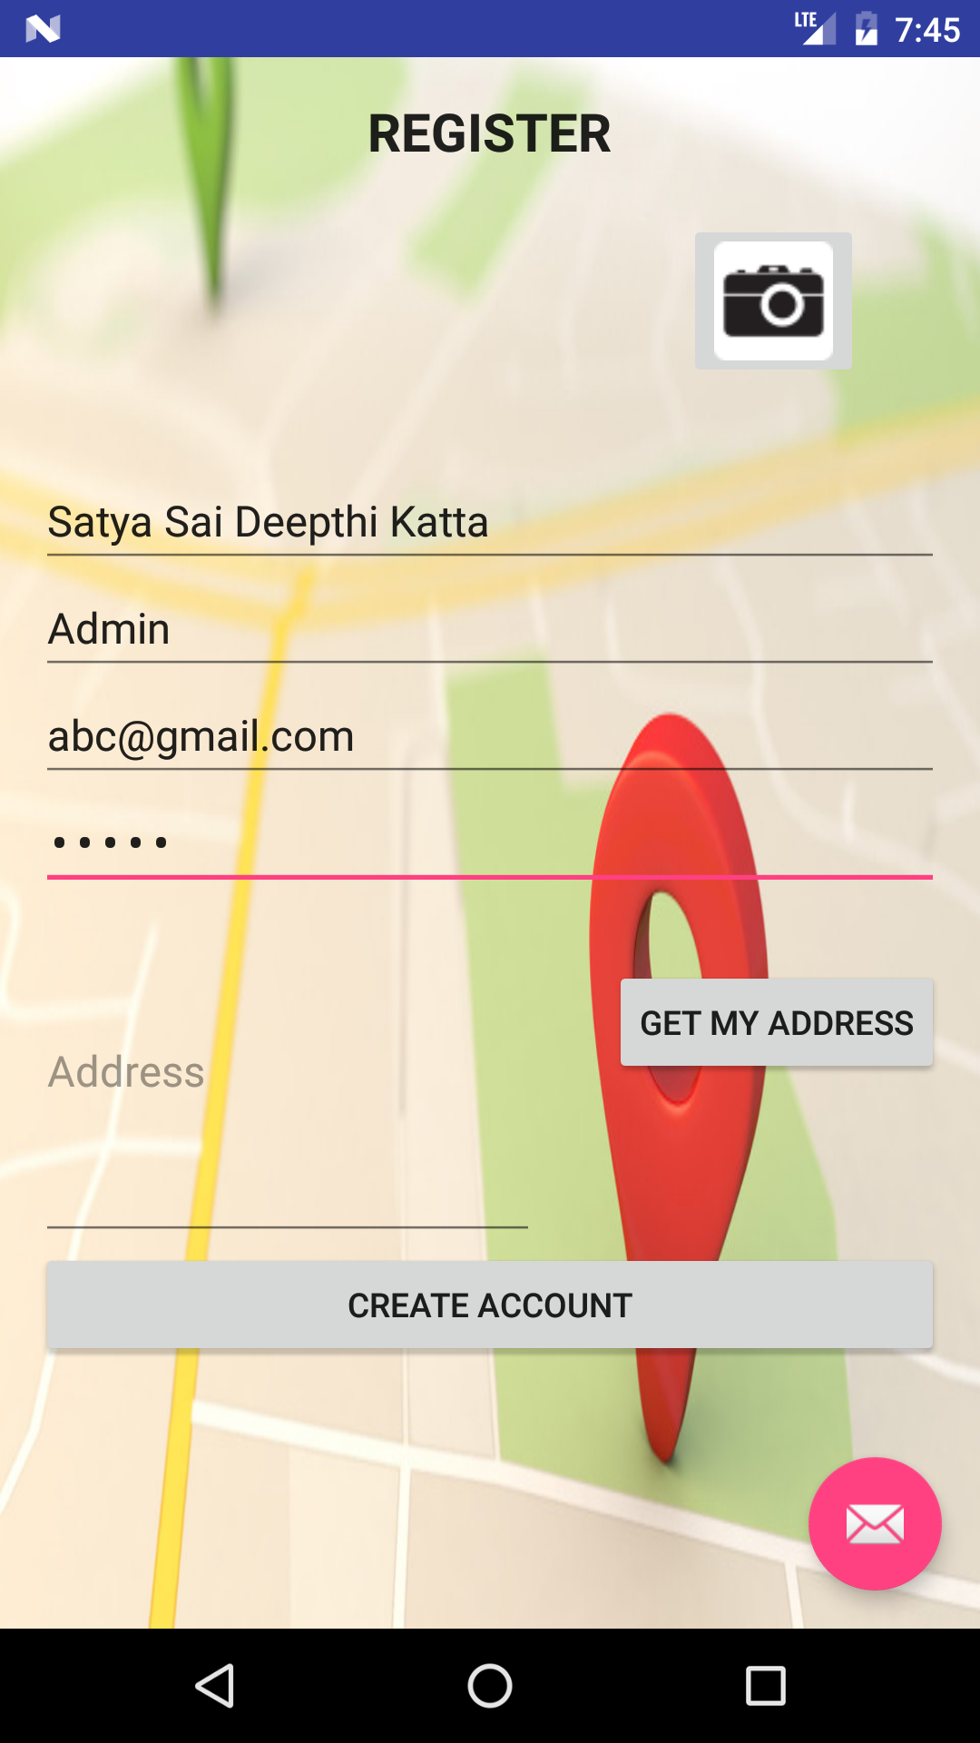

**Fig 6. Admin User creation in Registration Page.**

The image can be uploaded into the application by either capturing the image at that point or by uploading the image from the Photo Library.

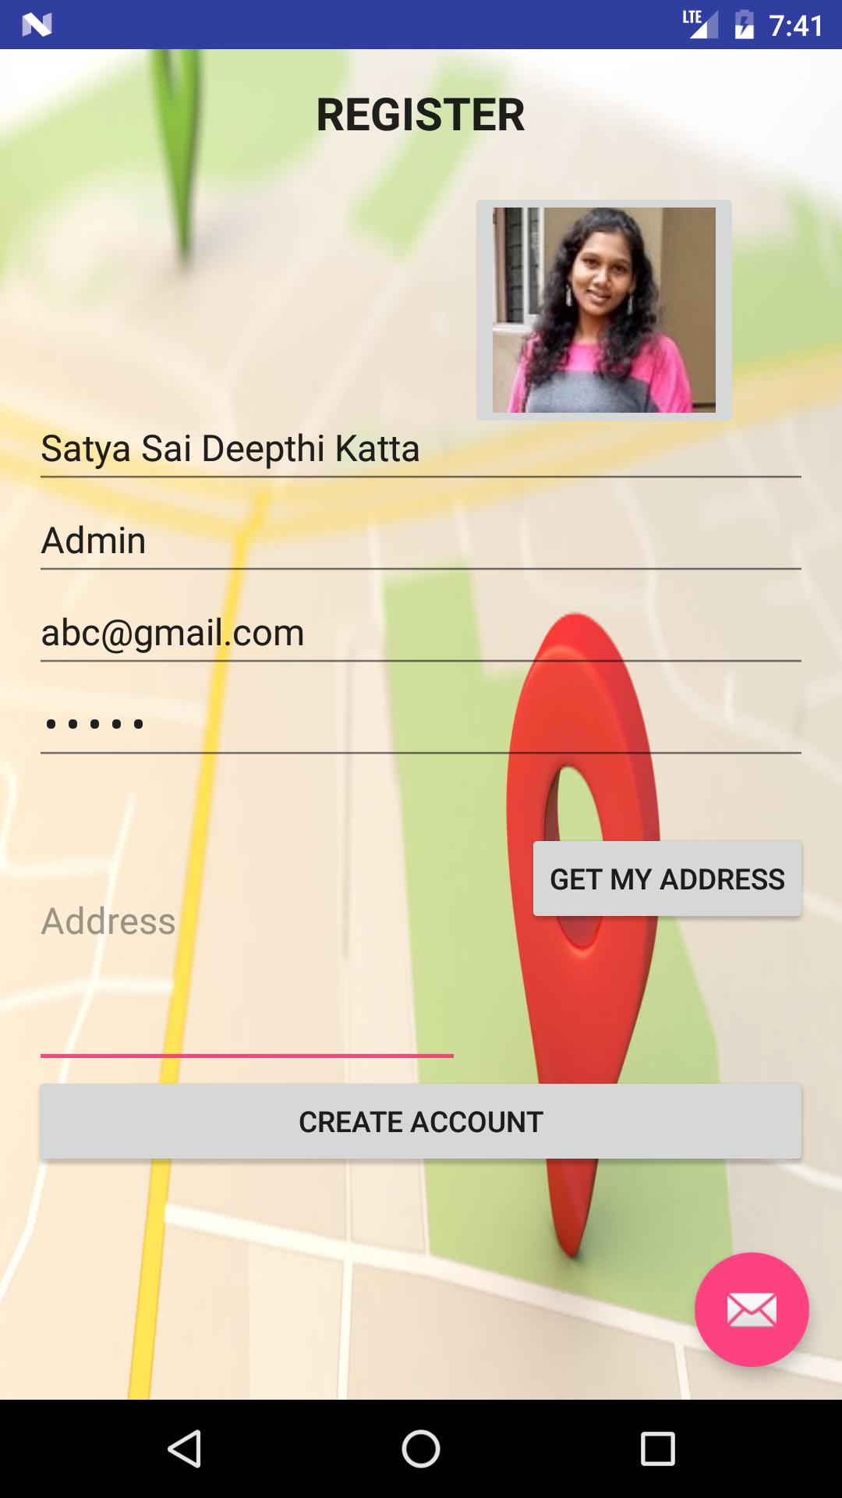

Fig 7. Photo is uploaded using image from Photo Library.

By clicking GET MY ADDRESS, current address is displayed using the GOOGLE MAPS LLOCATION API.

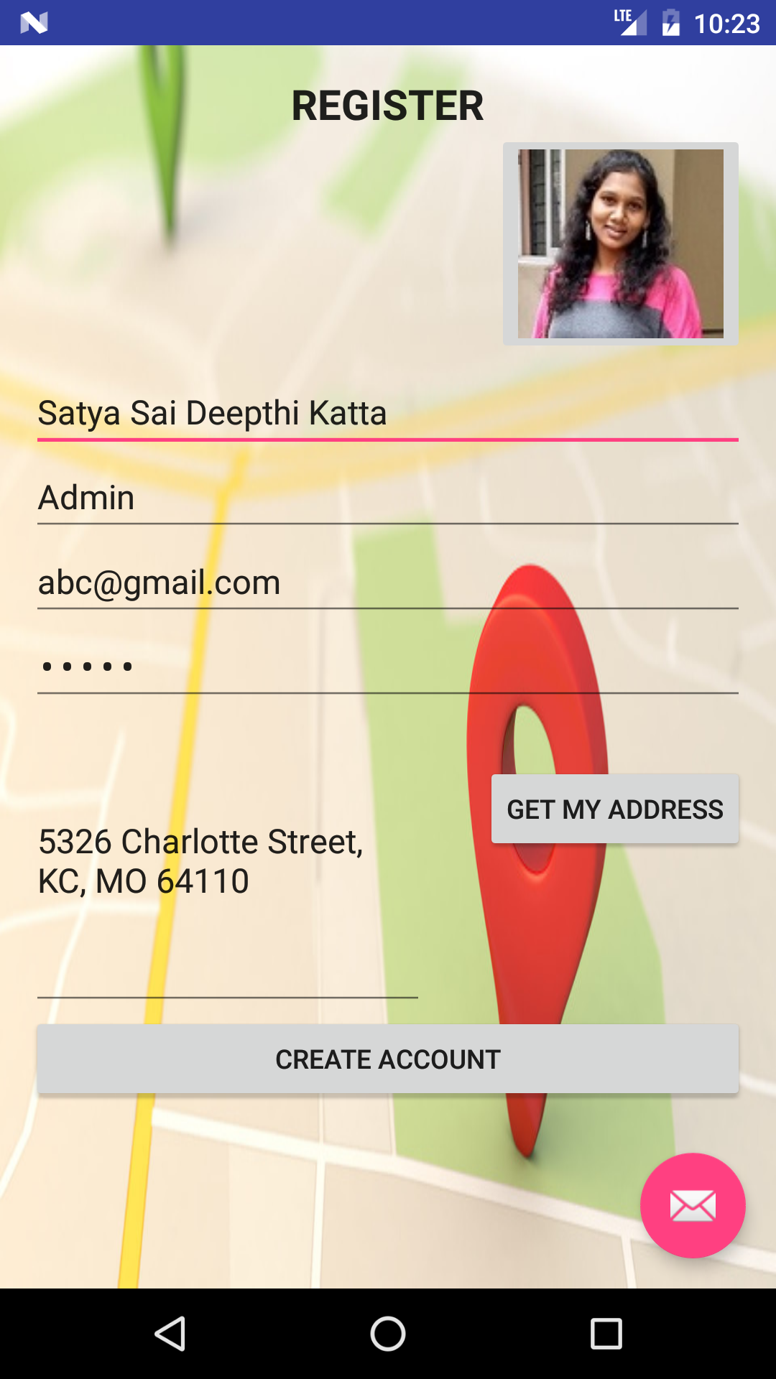

Fig 8. Displaying Location Address in Registration Page.

After successful registering into the application, user is redirected to login page to login into the app with the registered credentials.

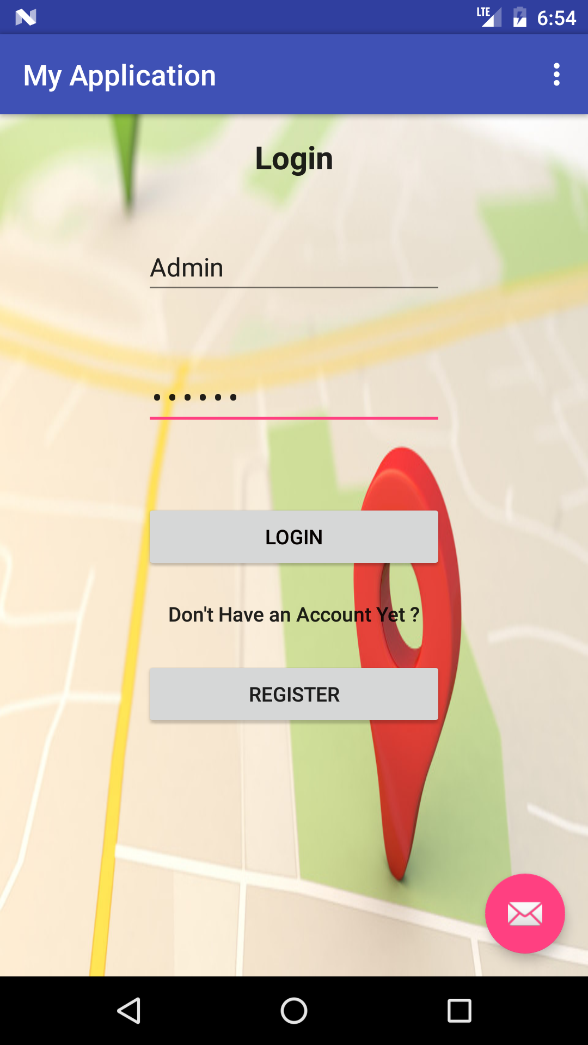

Fig 9. Using Admin account to login into the App.

Now the account is logged in with Admin credentials, the home page for My Location Application is displayed. The current location is displayed with image uploaded and address using GOOGLE MAPS API.

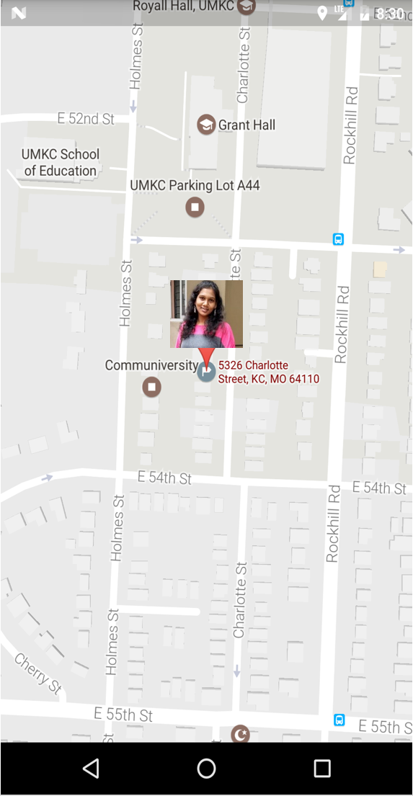

Fig 10. Current Location Address displaying with the Image in GOOGLE MAPS.